**PRACTICE QUESTIONS: TABULAR SUMMARY**

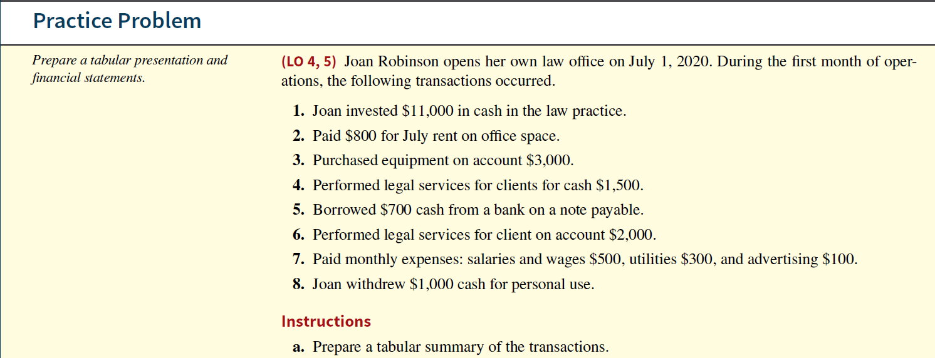  
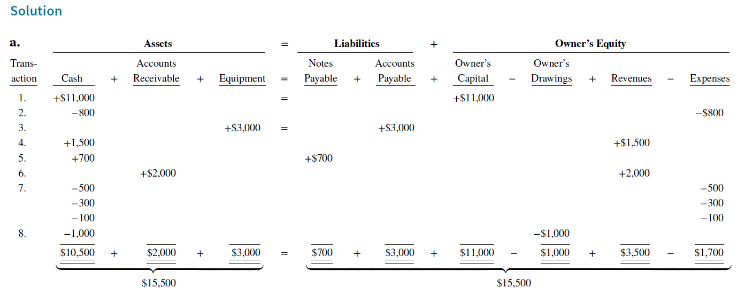

Q2.

On April 1, Julie Spengel established Spengel’s Travel Agency. The following transactions were completed during the month.

**1.** Invested $15,000 cash to start the agency.

**2.** Paid $600 cash for April office rent.

**3.** Purchased equipment for $3,000 cash.

**4.** Incurred $700 of advertising costs in the *Chicago Tribune,* on account.

**5.** Paid $900 cash for office supplies.

**6.** Performed services worth $10,000: $3,000 cash is received from customers, and the balance of

$7,000 is billed to customers on account.

**7.** Withdrew $600 cash for personal use.

**8.** Paid *Chicago Tribune* $500 of the amount due in transaction (4).

**9.** Paid employees’ salaries $2,500.

**10.** Received $4,000 in cash from customers who have previously been billed in transaction (6).

**Instructions**

**a.** Prepare a tabular analysis of the transactions.

Q3

Sonya Jared opened a law office on July 1, 2020. On July 31, the balance sheet showed Cash $5,000, Accounts Receivable $1,500, Supplies $500, Equipment $6,000, Accounts Payable $4,200, and Owner’s Capital $8,800.

During August, the following transactions occurred.

**1.** Collected $1,200 of accounts receivable.

**2.** Paid $2,800 cash on accounts payable.

**3.** Recognized revenue of $7,500 of which $4,000 is collected in cash and the balance is due in September.

**4.** Purchased additional equipment for $2,000, paying $400 in cash and the balance on account.

**5.** Paid salaries $2,800, rent for August $900, and advertising expenses $400.

**6.** Withdrew $700 in cash for personal use.

**7.** Received $2,000 from Standard Federal Bank—money borrowed on a note payable.

**8.** Incurred utility expenses for month on account $270.

**Instructions**

1. Prepare a tabular analysis of the August transactions

Q4

Maisie Taft started her own consulting firm, Maisie Consulting, on May 1, 2020. The following transactions occurred during the month of May.

May 1 Maisie invested $7,000 cash in the business.

2 Paid $900 for office rent for the month.

3 Purchased $800 of supplies on account.

5 Paid $125 to advertise in the *County News*.

9 Received $4,000 cash for services performed.

12 Withdrew $1,000 cash for personal use.

15 Performed $6,400 of services on account.

17 Paid $2,500 for employee salaries.

20 Made a partial payment of $600 for the supplies purchased on account on May 3.

23 Received a cash payment of $4,000 for services performed on account on May 15.

26 Borrowed $5,000 from the bank on a note payable.

29 Purchased equipment for $4,200 on account.

30 Paid $275 for utilities.

**PRACTICE QUESTIONS: GENERAL JOURNAL, T-ACCOUNTS & TRIAL BALANCE**

Q5

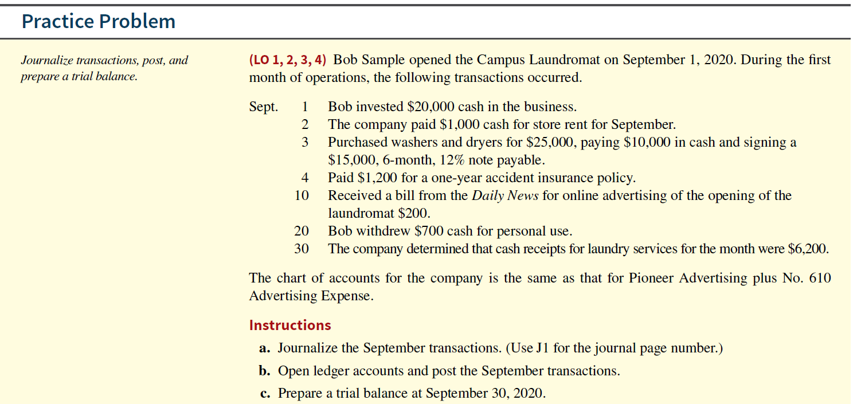

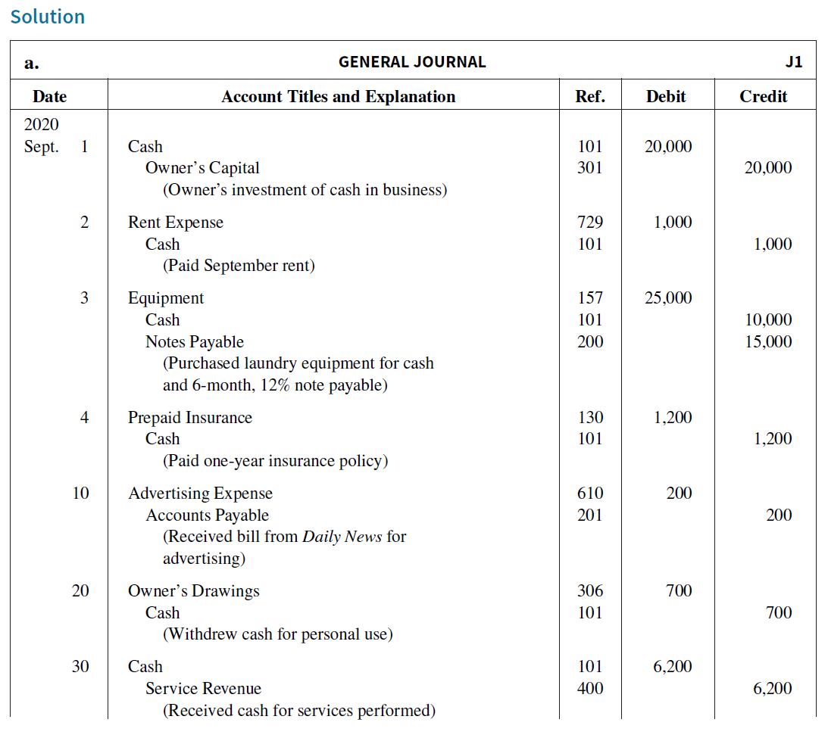

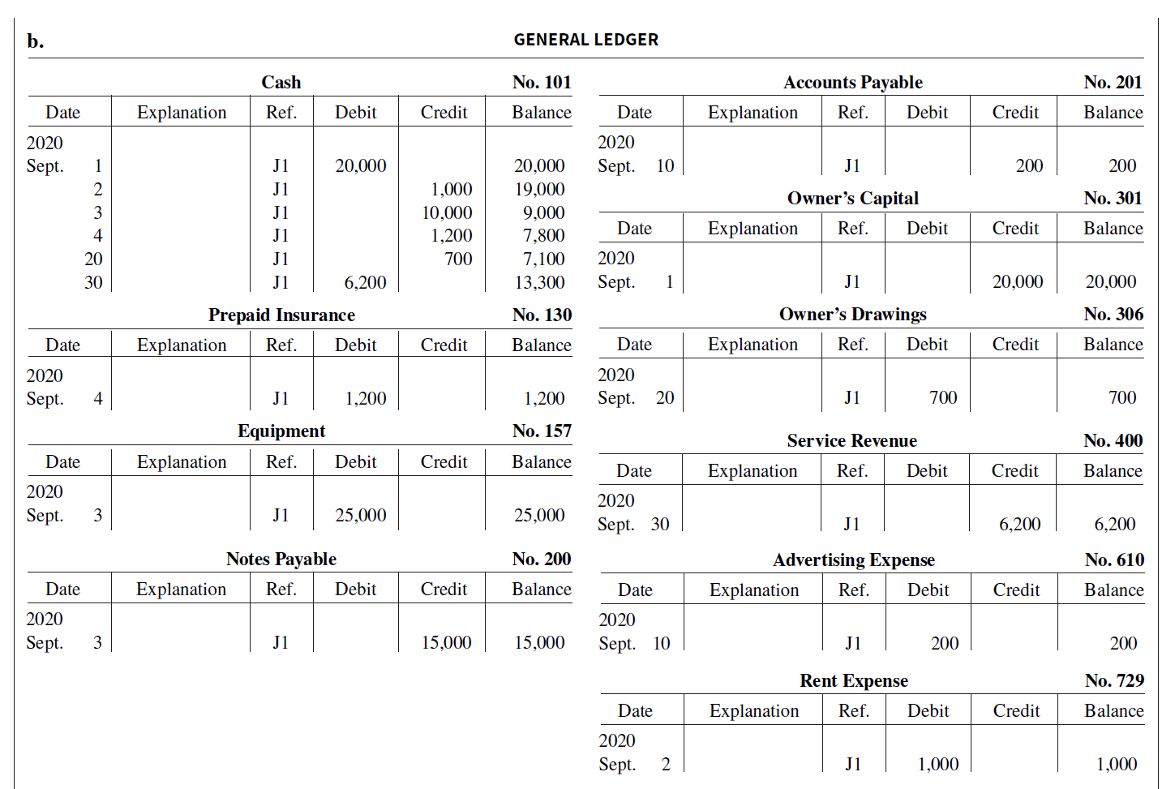

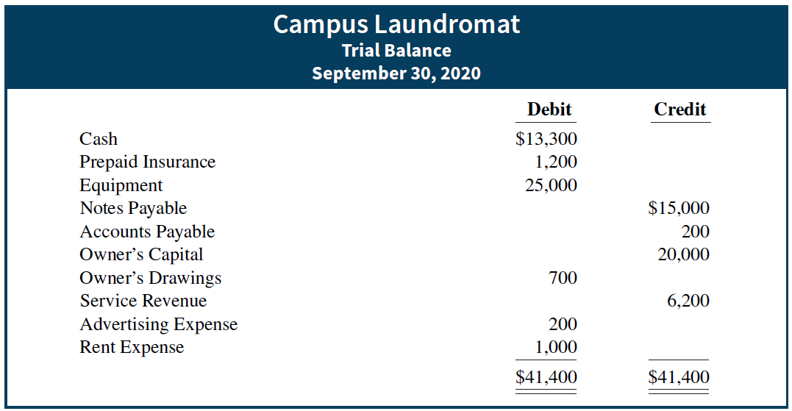

Q6

Selected transactions for Sophie’s Dog Care are as follows during the month of March.

March 1 Paid monthly rent of $1,200.

3 Performed services for $160 on account.

5 Performed services for cash of $75.

8 Purchased equipment for $600. The company paid cash of $90 and the balance was on account.

12 Received cash from customers billed on March 3.

14 Paid salaries and wages to employees of $525.

22 Paid utilities of $72.

24 Borrowed $1,500 from Grafton State Bank by signing a note.

27 Paid $220 to repair service for plumbing repairs.

28 Paid balance amount owed from equipment purchase on March 8.

30 Paid $1,800 for six months of insurance.

**Instructions**

Journalize the transactions.

Q7

On April 1, Adventures Travel Agency began operations. The following transactions were completed during the month.

**1.** Owner invested $24,000 in the business.

**2.** Obtained a bank loan for $7,000 by issuing a note payable.

**3.** Paid $11,000 cash to buy equipment.

**4.** Paid $1,200 cash for April office rent.

**5.** Paid $1,450 for supplies.

**6.** Purchased $600 of advertising in the *Daily Herald*, on account.

**7.** Performed services for $18,000: cash of $2,000 was received from customers, and the balance of

$16,000 was billed to customers on account.

**8.** Cash withdrawal of $400 by owner for personal use.

**9.** Paid the utility bill for the month, $2,000.

**10.** Paid *Daily Herald* the amount due in transaction (6).

**11.** Paid $40 of interest on the bank loan obtained in transaction (2).

**12.** Paid employees’ salaries and wages, $6,400.

**13.** Received $12,000 cash from customers billed in transaction (7).

**Instructions**

**a.** Journalize the transactions.

**b.** Post the transactions to T-accounts.

**c.** Prepare a trial balance at April 31, 2020.

Beyers Security Company provides security services. Selected transactions for Beyers are presented below.

Oct. 1 Invested $66,000 cash in the business.

2 Hired part-time security consultant. Salary will be $2,000 per month. First day of work will

be October 15.

4 Paid one month of rent for building for $2,000.

7 Purchased equipment for $18,000, paying $4,000 cash and the balance on account.

8 Paid $500 for advertising.

10 Received bill for equipment repair cost of $390.

12 Provided security services for event for $3,200 on account.

16 Purchased supplies for $410 on account.

21 Paid balance due from October 7 purchase of equipment.

24 Received and paid utility bill for $148.

27 Received payment from customer for October 12 services performed.

31 Paid employee salaries and wages of $5,100.

**Instructions**

**a.** Journalize the transactions. Do not provide explanations.

**b.** Post the transactions to T-accounts.

**c.** Prepare a trial balance at October 31, 2020.